February 13, 2017

Mrs. Nancy Bouchard
Mr. Mario Bouchard
22351 Columbia Street
Dearborn, MI 48124

Subject: Proper Issuance of Auto Repair Expense Payment to Mr. Paul V. Sheridan

Reference 1: Letter to You from Attorney Bryan Yaldou of November 18, 2016
Reference 2: Letter to You from Attorney Bryan Yaldou of December 6, 2016

Dear Mrs. Nancy Bouchard and Mr. Mario Bouchard:

It has come to the attention of this law firm that you are in receipt of References 1 and 2. In both letters it was requested that you issue a payment to the law firm in the amount of $282.34, which you have owed to Mr. Sheridan, now, for over eighteen months. Despite knowing of his legal representation, you circumvented proper legal channels, making direct contact with our client. Instead of issuing a payment to the law firm, as required, you orchestrated a check, issued by an unrelated third party that included verbiage which essentially bribed Mr. Sheridan. The details of this breach of protocol are discussed in the ‘Background – Part 7’ section below.

Given your ongoing behavior, and to ensure that the true record is clear, Mr. Sheridan has provided details on the following relevant ‘Background’ items. These items are based on his direct experience, direct witnessing, one-on-one interviews, and extensive documentation.

Background – Part 1

The debt of $282.34, for expenses-only, was incurred in July 2015 as a result of Mr. Sheridan’s offer to repair an automotive alternator that you had asserted was defective. Over a period of five days, Mr. Sheridan not only replaced the alternator but, due to your lack of care and competence, and due to its poor condition; he was compelled to repair many additional items on the 2005 Volkswagen, driven by your daughter Ms. Dayna Bouchard. This extra effort was necessary in order to return the vehicle to her in a safe working order. True to his character, Mr. Sheridan was in constant email contact with you; apprising you of the poor condition of the vehicle, the repair progress, and further repair needs (Attachment 1).

Upon return from your one-week trip (to Connecticut) on Saturday July 11, 2015, you found a box on your kitchen table which included all Volkswagen spare and repair items, two CDs containing detailed photographs of his repair efforts, and a polite billing from Mr. Sheridan.

On Monday morning, July 13, 2015, Mr. Sheridan responded to his front door bell, which was being rung by your daughter, Ms. Dayna Bouchard. Rather than offering the expected payment for the repair of her 2005 Volkswagen, she was instead requesting return of the keys to the Family Electric commercial van which you had been illegally parking in the City easement:

As you are aware, and as described in paragraph 5 of Reference 1, you had personally given those keys to Mr. Sheridan, and requested that he move the van. You were anticipating that routine police patrols would result in re-ticketing.

Background – Part 2

Mr. Sheridan asserts that you never offered the time, the courtesy or the care to review the cd, which contained numerous photographs that he had taken of your daughter’s Volkswagen, while he performed as many repairs as possible.

In fact, on or about July 23, 2015, Mr. Sheridan hosted you in his home office, wherein he reviewed with you those cd photographs. During this short session, recognizing the shabby condition of the Volkswagen, you made the following slanderous outburst:

That (explicative), I gave him the car to look it over before I bought it, and that (explicative) gave it a ‘clean bill of health’.”

The person(s) you were referring to was then identified (by you) as the owner and mechanics at the Dearborn Total Automotive group on Van Born Road in Dearborn Heights, Michigan:

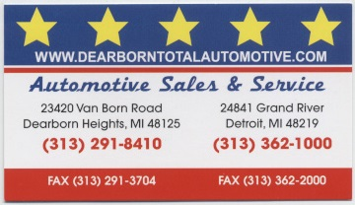

Shortly thereafter, Mr. Sheridan personally interviewed the owner and at least two mechanics of this auto service business. All were utterly flabbergasted with your claim, and all emphatically denied that any member of their business had inspected your daughter’s Volkswagen prior to your purchase. All went into detail, including a review with Mr. Sheridan of repair type and frequency, as well as the extensive repairs made necessary to the front of the Volkswagen after a major non-injury accident.

Mr. Sheridan believes that your outburst regarding the personnel of the Dearborn Total Automotive group is just another example of your penchant for slandering people. A small sampling of the repair photographs that Mr. Sheridan took of the Volkswagen can be found on Attachment 2.

After review of the photographs in his home, Mr. Sheridan advised you that the VW should be scrapped due to its unreliable and dangerous condition. Instead of heeding his expert advice, not only did you fail to scrap it but attempted to sell it, and in a show of apparent vindictiveness, you began parking the Volkswagen, not in front of your house, but in front of Mr. Sheridan’s house at 22357 Columbia Street:

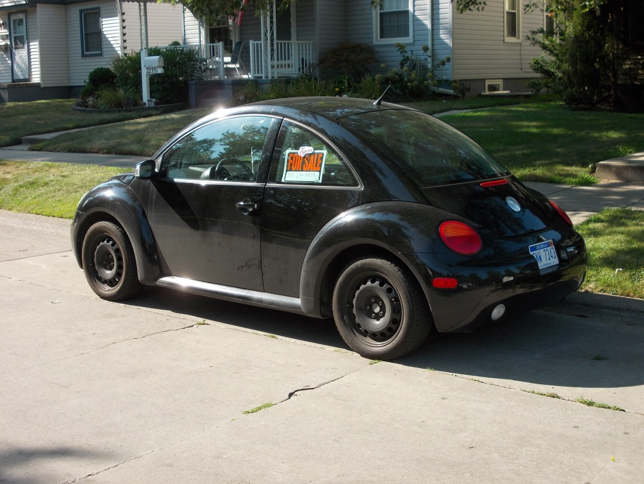

Background – Part 3 – Prior Reimbursement Abuses

To provide context, Mr. Sheridan has detailed the following history; one among many he has endured.

Prior to his repair of your daughter’s Volkswagen, once again at your request, Mr. Sheridan had been regularly maintaining the following grounds-keeping equipment:

lawn mower(s)
snow blower
lawn edger

During and since this generous repair performed by our client, you have enjoyed the resulting enhanced performance of these four pieces of equipment. During this time, once again, he only requested that you reimburse the cost of parts-only. He charged you nothing for his good work.

During this maintenance (which greatly improved the reliability, appearance and safety of this equipment) he accrued a total billing of $58.70. He gave you several polite notes requesting reimbursement, as well as several polite voiced reminders. Did you pay him within 14 hours? Or perhaps 14 days?

As you are both aware, it was only by happenstance that he was reimbursed at all. When he asked Mrs. Bouchard to remind Mr. Bouchard of the $58.70 debt, she handed Mr. Sheridan $60.00:

That payment took place a full FOURTEEN MONTHS after his polite memos.

This is just a portion of the historical context of ill treatment you have rendered against our client. During and since that time you have benefitted from his well-known technical skills; routinely using these three pieces of equipment without issue.
Background – Part 4 – Openly Libelous Accusation

In your secret submission to Dearborn City Council of January 20, 2016, a document you hoped would never be discovered by your neighbor of 28 years, you made the following libelous claim:

Attachment 3 is the listing of signatures of neighbors that you solicited in support of your knowingly false submission to Dearborn City Council. Mr. Sheridan has interviewed these neighbors and can state the following:

- A majority these neighbors have confirmed that you made slanderous accusations against our client similar to that found under ‘Background – Part 4’ above.
- Some of these neighbors have never met Mr. Sheridan, and have never had any “issues” with him of any kind.
- Those neighbors that do know him had nothing but complimentary remarks regarding his person, with the most negative comment being, “He’s so quiet, we never know if he’s home or not!”
- All of the neighbors interviewed stated that you had made one or both of the following false claims: a) that you are a licensed electrician, b) that you are on emergency 24-hour call as part of your employment routine.

Item 4 is was claimed in writing or intimated by word during your official representations to a government body: The City of Dearborn. But Item 4 is especially egregious since, as you are fully aware, your prior and current employers have never elevated you to such status. In fact, in their submission to the City your former employer offered no connection whatsoever between your claims (to the City, neighbors and third parties) and the requirements for a commercial vehicle parking waiver. That former employer openly stated:

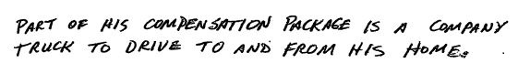

In truth, your submissions to the City are an attempt to ameliorate a personal financial situation, with which the City, neighbors, third parties, and Mr. Sheridan have had no involvement. Your motivation was to use the employer’s commercial vehicle as a commuter vehicle. But, in your secret submission of January 20, 2016 you stated the following diversion:

As you are fully aware, your then-existing financial situation and your spending habits are not relevant to the City requirements of a commercial vehicle waiver, especially those stated by the Dearborn Police Department Traffic Safety Bureau (TSB).

Your personal spending habits are unabated. Although you did not disclose this fact to the City, during the time of your “financial hardship” claims, you acquired a brand new Ford Focus (Attachment 4).
Background – Part 5 – Reason #1 for Avoiding Solicitation of Required Waiver Approval

In your secret submission to Dearborn City Council of January 20, 2016, you submitted the following utterly absurd diversionary fabrication:

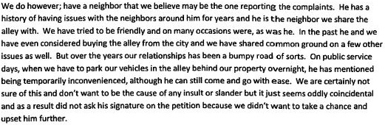

As you are fully aware, at no time “on public service days” has Mr. Sheridan “mentioned being temporarily inconvenienced.” This fabrication slanders Mr. Sheridan, portraying him as an unreasonable and unreasoning neighbor. Mr. Sheridan would never lodge such a ludicrous impractical complaint.

But more importantly, and more relevantly, the diversionary character of your secret submission is borne by the facts surrounding your threatening and violent behavior of July 30, 2015. Well-known to both of you, it was your unprovoked acts of that day that forever obviated your relationship with a fine neighbor of over twenty-seven years. You launched into unbridled yelling and screaming across the fence at Mr. Sheridan, over what amounts to proverbial nickels & dimes:

Apparently you had made the unilateral decision that if Mr. Sheridan is unwilling to serve as your personal banker, then he must therefore simultaneously be “the one reporting the complaints.”

As City officials have already confirmed, at no time prior to learning of your secret libelous submission to City Council did Mr. Sheridan make any complaints about your illegal parking of commercial vehicles on City property. In fact, it was after the City of Dearborn Legal Department received and reviewed your secret submission to City Council; a submission you did not anticipate Mr. Sheridan would acquire, that the Dearborn Police Department searched for neighbor complaints received during 2015. Contrary to your libelous accusation, there is no record of Mr. Sheridan “reporting the complaints” (Attachment 5).

On the other hand, your duplicitous character is borne by the portent of paragraph 5 of Reference 1:

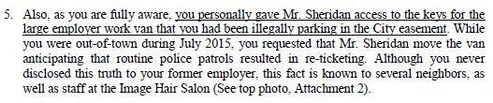

So, on the one hand, when it serves your agenda, Mr. Sheridan is expected to provide (illegal) valet services, but when otherwise he is libeled as the person “reporting the complaints”?

Attachment 6 describes and documents your actions of July 30, 2015; one of the true reasons that you “did not ask his signature on the petition (sic).”
Background – Part 6 – Reason #2 for Avoiding Solicitation of Required Waiver Approval

An additional reason that you avoided asking Mr. Sheridan for the required neighbor approval involved your knowledge of his personal and professional integrity. In this context you were fully aware that he would not participate in your scheme to deceive Dearborn City Council regarding your claim of being a licensed electrician, and your claim of being on 24-hour emergency call. You were aware that he would not sign any official documents, destined for the public files of a government body, that contained any conscious falsehoods. Aware of his integrity, and his direct knowledge of your true licensing and employment status, you were compelled to mislead City officials as described in Part 5 above.

Background – Part 7 – Recent Developments and Ongoing Slanderous Abuse

It has come to the attention of this law firm that you announced receipt of Reference 2, during regular business hours, at the Image Hair Salon. Once again, you are involving people that have no connection to the neighborhood issues that you have created. You also once again made slanderous statements against Mr. Sheridan, regarding his motivations and person; this time with words very similar to:

“Well, as we expected he (Mr. Paul Sheridan) didn’t accept the check . . .”

These and other disparaging comments, were directed at the salon co-proprietor Ms. Carol Christopher and her employee Mr. Daniel Dykas. Other employees, as well as patrons, were present during and after these and related slanderous comments were circulated about our client.

Mr. Sheridan is confident that you failed to describe to these Image Hair Salon employees the details of why he was advised, by his prior legal counsel, to once again reject your check.

Specifically, despite knowing that he was represented by legal counsel, you purposely circumvented proper legal channels, making direct contact with our client. Instead of issuing a payment to the law firm, as required, you orchestrated a check issued by an unrelated third party, that included verbiage which essentially attempted to bribe Mr. Sheridan:

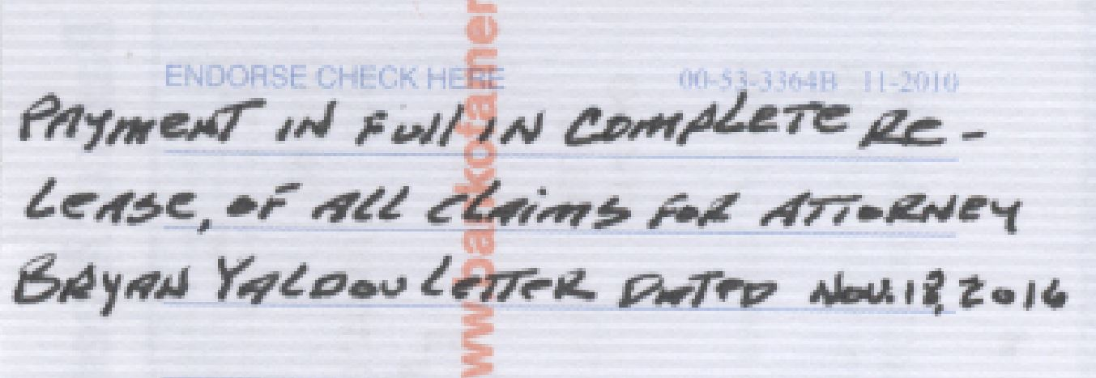

You are fully aware of the upcoming lawsuits of slander and libel against you. In this context, as shown on the screenshot of the check that you had forwarded to our client, you attempted to circumvent the libel issue by bribing Mr. Sheridan . . . WITH MONEY THAT YOU OWE HIM.

Final Notice

You are hereby directed to issue to this law firm, payable to Mr. Paul V. Sheridan, payment of the outstanding debt, of eighteen months, in the amount of $282.34.

If this payment is not received within 7 business days subsequent to your receipt of this letter, an additional legal action will be taken against you.

This is an attempt to collect a debt. Any information received will be used for collection purposes.

DAVID E GHANNAM, PC

BY: DAVID E GHANNAM

Attachments

For the record, there is no “Monday Aug. 2” in calendar year 2015 (See second page of instant Attachment 6.)

