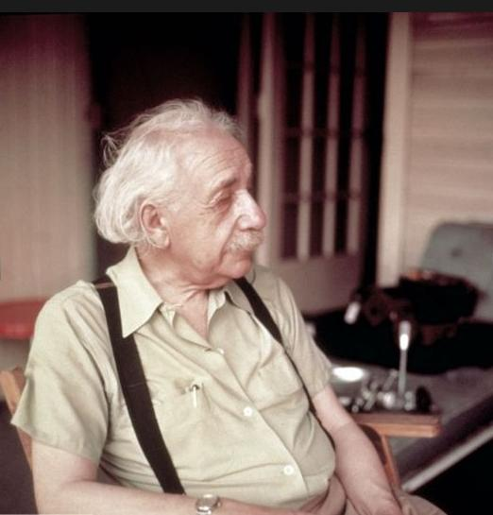

“We men are deplorable creatures. But compared with these women, every one of us is king, for he stands more or less on his own two feet, not constantly waiting for something outside of himself to cling to. They, however, always wait for someone to come along who will use them as he sees fit. If this does not happen, they (women) simply fall to pieces.”

Albert Einstein, Princeton University Press, The Expanded Quotable Einstein, (2000) pages 306 – 307.

