22357 Columbia Street

Dearborn, MI 48124-3431

313-277-5095

pvs6@cornell.edu

16 December 2020 Via FedEx AirBill 8007-9341-6720

Dr. Anthony S. Fauci, Director

National Institute of Allergy and Infectious Diseases

5601 Fishers Lane

Rockville, MD 20892

301- 496 - 5717

**Subject : I Hereby Accuse You of ‘Gross Criminal Negligence’**

**Connectable to the Death of Mr. Spencer William Smith [1]**

**Reference : Mandatory Vaccination Against Suicide**

Dear Dr. Fauci:

Are you familiar with Mr. Spencer William Smith, pictured at-right:

[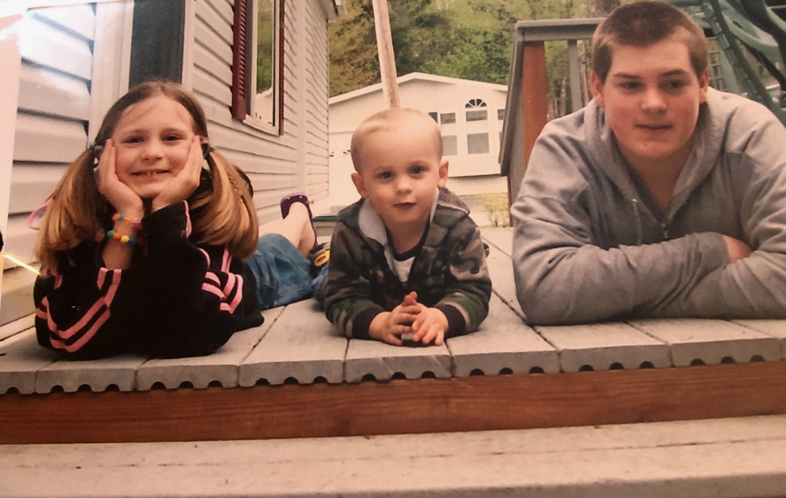](https://youtu.be/bJCvOe87eg4)

**I hereby accuse you (and others) of Gross Criminal Negligence, which is directly connectable to the suicide death of 16-year-old Spencer**. This charge is purposely narrow;

I am confident additional civil and criminal charges are evidentiary/supportable, in this and other related matters, and will therefore be sustained in the near future.

16 December 2020 Dr. Anthony S. Fauci

Page 2 of ??

We review the Gross Criminal Negligence law:

*“ Gross negligence is culpable or criminal when accompanied by acts of commission or omission of a wanton or willful nature, showing a reckless or indifferent disregard of the rights of others, under circumstances reasonably calculated to produce injury, or which make it not improbable that injury will be occasioned, and the offender knows or is charged with knowledge of the probable result of his/her acts; ‘culpable’ meaning deserving of blame or censure*.”

You are aware that I had discussed this specific issue, regarding your person, with the

treasonous US Attorney General Mr. William P. Barr on 28 August 2020 (Attachment 1).

I also alerted you to this law in 21 July 2020 on Page 24 of a 36-page letter. I discussed ten areas regarding the so-called “COVID-19 pandemic.” I opened with your quote of 10 July 2020 to the Financial Times of London (Attachment 2) :

*“ I have a reputation, as you probably have figured out, of speaking the truth at*

*all times and not sugar-coating things. And that may be one of the reasons why*

*I haven’t been on television very much lately.”* **[2]**

Consistent with historical and ongoing behavior, **and contrary to your self-effacing crap about *“speaking the truth at all times*,”** you failed to offer the courtesy of a response:

Had you done so, the death of Spencer William Smith would have been avoided.

**Your Two Most Prominent Lies - How Such Led to the Death of Spencer William Smith**

We are now beyond the ten items discussed in Attachment 2. In this communication, we now focus on your two most prominent lies / frauds:

1. Your lie that the only way the United States can attain “herd immunity” is through vaccination; attained at a market penetration of *“75%”* (your baseless statistical claim).

2. Your bold-faced lie that the PCR process can be modified through “amplification,” and *then* deployed world-wide as the “gold standard” (for detection of what has been labeled SARS-CoV-2) for determination of COVID-19 infection.

Both lies, and much more, are relevant to the charge of Gross Criminal Negligence. I will show that your rampant demand for enforcement of “lockdowns,” which you justify on the basis of these two lies, is directly connectable to the death of a 16-year-old high school boy.

16 December 2020 Dr. Anthony S. Fauci

Page 3 of ??

**Discussion – Fauci Lie #1**

1. Your lie that the only way the United States can attain “herd immunity” is through vaccination; attained at a market penetration of *“75%”* (your baseless statistical claim).

In Attachment 2, pages 4-8, I reviewed the anti-hydroxychloroquine “studies” and the corporate news propaganda; but most notably your promotion of the Surgishpere report.

You were fully aware that the Surgisphere report was a fraud; so fraudulent that the global community of medical doctors (who uphold the Hippocratic Oath, offering *real* health & well-being) were so outraged that thousands protested that “study,” **thereby forcing its retraction.** **[3]**

[](https://youtu.be/3lJoRn1Ugs8)That retraction, and the efficacy

of hydroxychloroquine, was also detailed on 23 August 2020 by Mark Levin and renowned Yale professor Dr. Harvey Risch.

**In the context of my (initial) charge against you, Gross Criminal Negligence**, your proclamations that treatments using hydroxychloroquine are dangerous, **is a lie.**

[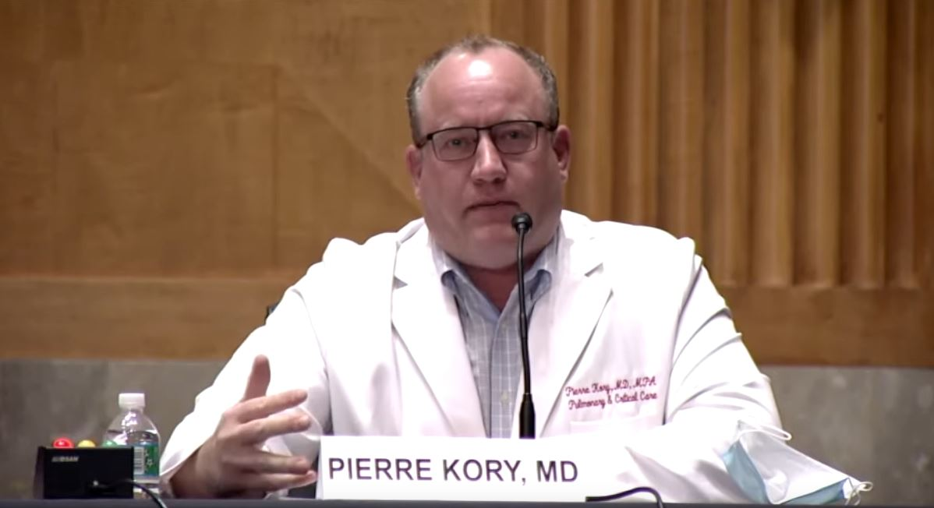](https://youtu.be/Z2fzoF3qB3k)

You are aware of treatments, and patient success, from nebulized budesonide to ivermectin. The latter was testified-to by Dr. Pierre Kory at the Senate Committee on Homeland Security and Governmental Affairs on 8 December 2020. Dr. Kory relies on his professional experience, and over 30 peer-reviewed studies, **not your cheap orchestrated Surgishpere crap.** **[4]**

Your proclamations that “herd immunity” against “COVID-19” can *only* be attained by vaccination, **is a lie.** As Dr. Cory testified, the CDC/FDA never even tasked-for repurposed medicines such as ivermectin; ***why not!?* [5]**

But let us review an example of immunity, established without the needles that you and your comrades profit from . . . **A globally auspicious example of immunity that you are fully**

**aware of; attained through the use of nutrition and treatments . . .**

16 December 2020 Dr. Anthony S. Fauci

Page 4 of ??

**Discussion – Fauci Lie #1** – conclusion

1. Your lie that the only way the United States can attain “herd immunity” is through vaccination; attained at a market penetration of *“75%”* (your baseless statistical claim).

[](http://pvsheridan.com/Sheridan2Melania-3-23July2020.pdf)

In 24 November 2020, to the vaccine-promoting Delta Airlines CEO Ed Bastian, I explained: **[6]**

[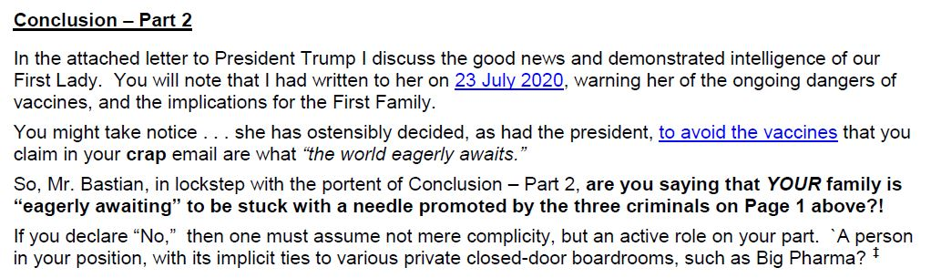](http://pvsheridan.com/sheridan2bastian-1-24november2020.pdf)

Unlike you and The Swamp, the First Lady not only responded to previous communication, it appears that she has acted on such. **[7]**

16 December 2020 Dr. Anthony S. Fauci

Page 5 of ??

**Intermission : The Pandemic Resume of Anthony Fauci**

Before we discuss Lie #2 I am compelled to once-again quote Dr. Kary Mullis, Nobel Prize winning inventor of the PCR process. Interviewed by Dr. Gary Null, Dr. Mullis describes your pandemic resume:

“What is it about humanity that it wants to go to all the details . . . guys like **Fauci** get up there and start talking, he doesn’t know anything, really about anything, and I would say that to his face. Nothing! The man thinks you can take a blood sample, stick it in an electron microscope, and if it has got a virus in there you will know it. He does not understand electron microscopy. He does not understand medicine. He should not be in the position he is in.

Most of those guys up there on the top are just total administrative people, and they do not know anything about what is going on at the bottom. Those guys have got an agenda, which is not what we would like them to have, being that we pay for them to care of our health. They have a personal kind of agenda, they make up their own rules as they go, they change them when they want to. And they smugly; like **Tony Fauci** does not mind going on television, in front of the people that pay his salary (taxpayers), and lie directly into the camera.

You cannot expect the sheep to really respect the best and the brightest. They do not know the difference. I like humans, do not get me wrong, but basically there is a vast majority of them that do not possess the ability to judge who is, and who is *not* really a good scientist. That is a main problem with science, the main problem with science in this century. Science is being judged by people, funding is being done by people (taxpayers) who do not understand it (science).

I mean . . . who do we trust? **Fauci? Fauci** does not know enough. If **Fauci** wants to get on television with somebody that knows a little bit about this stuff and debate them? **He could easily do it, because he has been asked!**

I mean I have had a lot of people; the president of the University of South Carolina has asked **Fauci** if he would come down there and debate me on the stage in front of the student body. Because I wanted somebody who was from the other side, to come down there and balance; because I felt like, well they could listen to me, but I need to have somebody else down here that was going to tell them about the other side. **Fauci . . . he did not want to do it.”**

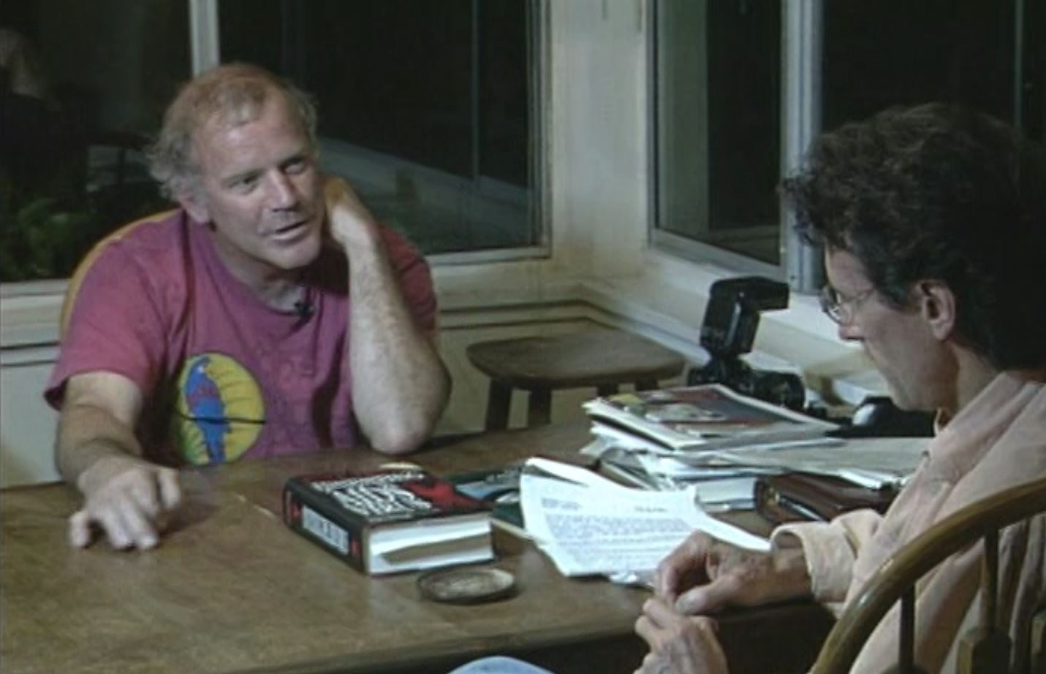

16 December 2020 Dr. Anthony S. Fauci

Page 6 of ??

**Intermission : The Pandemic Resume of Anthony Fauci** - conclusion

That quote from Dr. Mullis (pictured with monumental work of Dr. Peter Duesberg, [*Inventing the AIDS Virus*](https://www.researchgate.net/publication/261948355_Inventing_the_AIDS_Virus)*)* **contradicts your protestations** to the Financial Times of London:

*“ I have a reputation, as you probably have figured out, of speaking the truth at all times*

*and not sugar-coating things. And that may be one of the reasons why I haven’t been*

*on television very much lately.”*

Relating to the late-1980’s work of Dr. Duesberg, and your *ongoing* pandemic resume, **I quoted renown Yale professor Dr. Harvey Risch** on pages 7-8 of Attachment 1:

*“Somehow we have let politics overrule science, and it is an absurd situation that people have*

*compared to ‘1984’ and ‘The Ministry of Truth’ and so on; that is limiting what people can say on*

*objective facts, it is beyond belief ! . . . I think ‘they’ know the (hydroxychloroquine) treatment works. I think that basically they are afraid to even let it be tried, because letting it be tried would show that it works. So the message has to be shut at all costs, because anything will leak out, and in fact it is leaking out, and you see across the country, people who started to speak up, who become almost deathly ill, and have been turned around in three days or sooner even, and these are now public figures who are speaking up, who have said that the medicine hydroxychloroquine saved their life. And it is very difficult to, you know, close all the leaks in that dike that are being suppressed by the media that are trying to do that.”*

*This has gone on before . . . now we have Dr. Fauci denying that any evidence exists of benefit,*

*and that has pervaded the FDA. The FDA has relied on Dr. Fauci and his NIH advisory groups to*

*make the statement saying that there is no benefit of using hydroxychloroquine in outpatients, and this is*

*counter to the facts of the case. The (positive) evidence is overwhelming. The FDA has also said*

*that there is harm in using these medications in outpatients (that) overweighs the benefits. Ninety per cent of the COVID cases have occurred since the FDA restricted (hydroxychloroquine usage) to inpatients-only. Dr. Fauci and the FDA are doing the same thing that was done in 1987, and that has led to the (COVID-19) deaths of hundreds of thousands of Americans that could have been saved by usage of this drug.”*

**This has gone on before !?!**

Your previous guilt under ‘Gross Criminal Negligence’ is additionally supportable by the statement of

Dr. Risch. He presented your lack of objective, scientific assessment of the life-saving benefits to AIDS patients of inexpensive anti-biotics, such as sulfamethoxazole and trimethoprim (Bactrim). In answering that *‘gone on before’* question, Dr. Risch states that **your favoritism toward profitable expensive vaccines was directly connectable to the death of over 17,000 human beings, quote:**

**“This was started most noticeably in 1987 . . . Seventeen-thousand people died because of Dr. Fauci’s insistence on not allowing even a statement supporting consideration of the use (of Bactrim).”**

Not allowing a statement? In the 1980s? And **now** your sputum of 27 May 2020 to *Politico* claiming that there is no benefit to hydroxychloroquine!? A mere introduction of your Pandemic Resume. **[8]**

16 December 2020 Dr. Anthony S. Fauci

Page 7 of ??

**Discussion – Fauci Lie #2**

2. Your bold-faced lie that the PCR process can be modified through “amplification,” and *then* deployed world-wide as the “gold standard” (for detection of what has been labeled SARS-CoV-2) for determination of COVID-19 infection.

On 21July 2020, **predating the suicide death of Spencer William Smith by five months,**

I requested your responses to questions regarding “COVID testing.” You ignored me.

In contrast, the good Governor of Florida Ron DeSantis did **not** ignore that very same letter **[9]**

Memo: I emphasize, as elaborated in the Conclusion, it is abundantly clear, **had the Smith family merely resided in Florida,** wherein “lockdowns” are reduced to non-existence, the schools are open and the students enjoy normal social interactions, **the probability of the suicide death of 16 year-old Spencer William Smith drops to zero.**

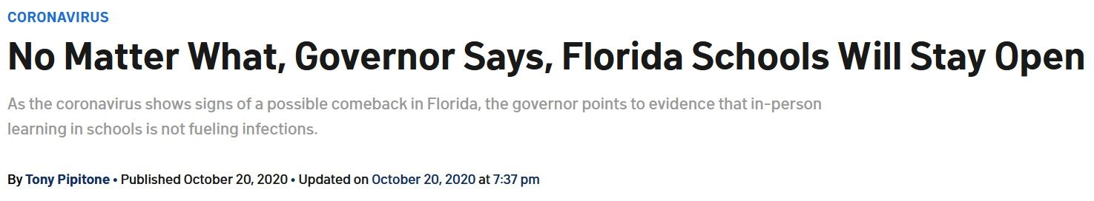

That byline, that insane drum-beat of your comrades in the corporate media,

is fueled by **Fauci Lie #2***.*

The incessant media and politician **crap** about *“cases”* is fueled **by *not* following the science;**

it is fueled by degrading science to charlatanism . . . by denigrating science to the point that the admonition *“follow the science”* is just another political ruse, a phrase worthy of only mindless WOKE diatribe . . . the byline is fueled by misrepresenting what science can and can *not* do. These misrepresentations that have no connection to the rigors of that honorable human activity.

But with respect to your PCR based “gold standard” . . . **If there is anyone that is *not* following the science, and encouraging others to *not* ‘follow the science,’ *it’s you!***

That Governor DeSantis ***is*** ‘following the science’ is borne by Attachment 3. His action will prove pivotal to ending your “cases” based lockdowns that have devastated New York, Michigan, Pennsylvania, the Bolshevik-inspired disaster called “California” . . . the entire USA.

. . . and most relevantly to ensuring that a “cases” based lockdown-premised nightmare, such as what occurred in the State of Maine on December 4, 2020, never happens again. **[10]**

16 December 2020 Dr. Anthony S. Fauci

Page 8 of ??

**Discussion – Fauci Lie #2** – con’t

2. Your bold-faced lie that the PCR process can be modified through “amplification,” and *then* deployed world-wide as the “gold standard” (for detection of what has been labeled SARS-CoV-2) for determination of COVID-19 infection.

As the non-science person easily understands by reviewing Attachment 3, the central theme of Governor DeSantis’ order is what I reviewed with you long-before December 4, 2020:

**Your implicit fraud of instituting/endorsing “amplification” of the PCR process,**

a process that the Nobel Prize winner/inventor of the PCR process told you, DIRECTLY, could *not* be deployed for definitive or specific virus detection . . . your so-called “gold standard.”

[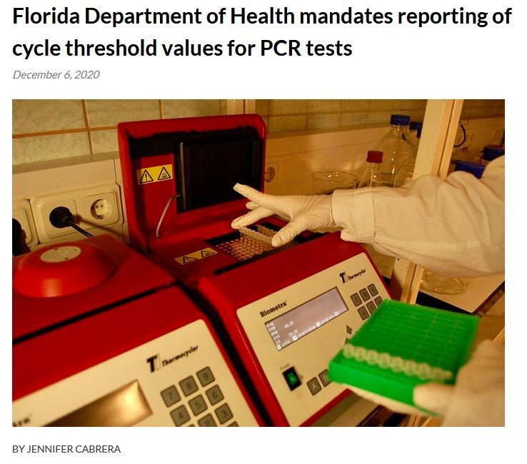](https://alachuachronicle.com/florida-department-of-health-mandates-reporting-of-cycle-threshold-values-for-pcr-tests/)

16 December 2020 Dr. Anthony S. Fauci

Page 9 of ??

**Discussion – Fauci Lie #2** – conclusion

2. Your bold-faced lie that the PCR process can be modified through “amplification,” and *then* deployed world-wide as the “gold standard” (for detection of what has been labeled SARS-CoV-2) for determination of COVID-19 infection.

As you are *fully aware*, the PCR process, and its misapplication to “COVID-19 testing,” deployed by Delta Airlines, Cornell University, the State of Maine, **is NOT quantitative, it is qualitative; with outputs utterly dependent on the Cycle Threshold Value (aka “amplification”) now demanded by the State of Florida.**  In this context I take exception to the following headline:

[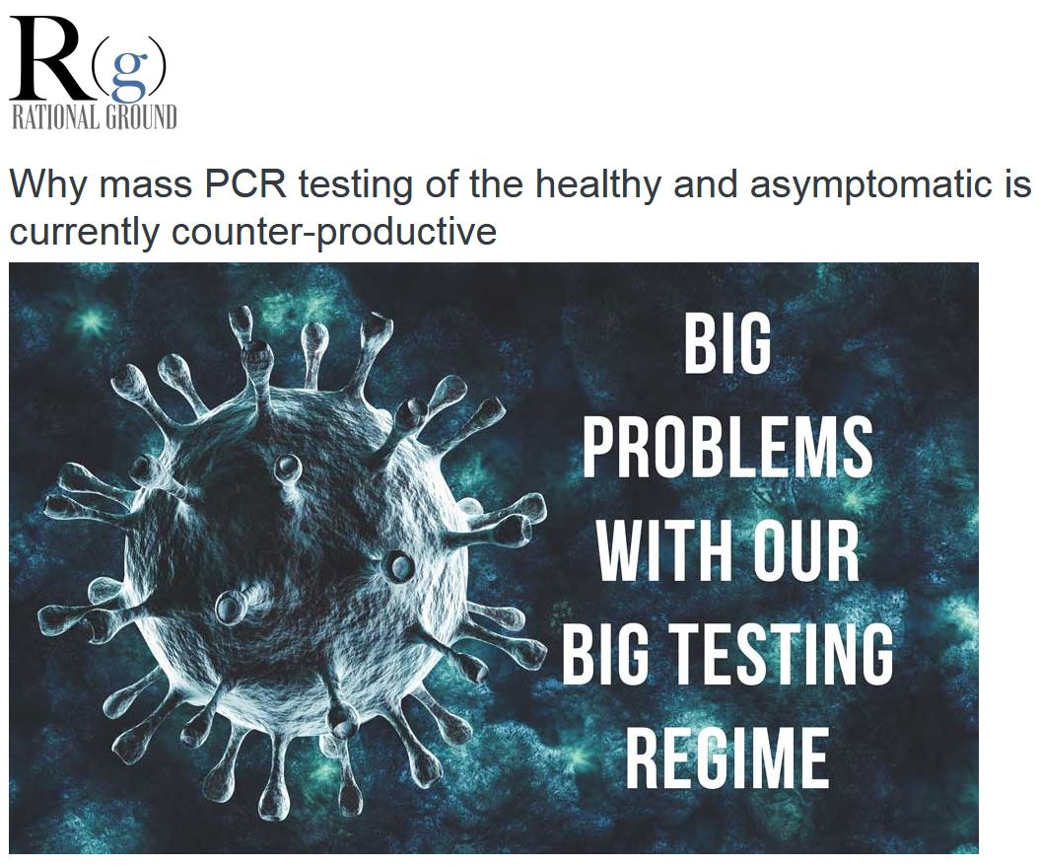](https://rationalground.com/why-mass-pcr-testing-of-the-healthy-and-asymptomatic-is-currently-counter-productive/)

Whilst you and your comrades celebrate the “Big Testing Regime” (despite [Quest Diagnostics](https://www.cnbc.com/2020/09/01/florida-drops-quest-for-coronavirus-testing-after-lab-reports-backlog-of-75000-test-results.html)), having made and continuing to make fortunes while that regime is enforced, the notion that

*“PCR testing of the healthy and asymptomatic is currently counter-productive”* is irresolute . . .

**The Big Testing Regime is not merely “currently,” or merely counterproductive . . . it has ALWAYS been counter-productive, and in-truth has now proven deadly, and not just to the Smith Family of Maine. Were it not for the fraud of “amplification,” central to your lies of PCR-based testing as the “gold standard,” the governor of Maine would not have had statistical “confirmed cases,” and therefore would be unable to enforce** [**the lockdown**](https://www.necn.com/news/coronavirus/covid-19-isolation-caused-maine-teen-to-kill-himself-parents-say/2366643/) **that 16-year-old Spencer William Smith** [**had connected in the suicide note as his primary reason to take his own life . . .**](https://www.necn.com/news/coronavirus/covid-19-isolation-caused-maine-teen-to-kill-himself-parents-say/2366643/)

16 December 2020 Dr. Anthony S. Fauci

Page 10 of ??

**Discussion : The Destiny of Two Sixteen Year Old Boys – A Stark Comparison**

Take a look at the following photographs Dr. Fauci . . . ***take a good looooooong look*:**

|  |  |
| --- | --- |
|  |  |
|  |  |
|  |  |

16 December 2020 Dr. Anthony S. Fauci

Page 11 of ??

**Discussion : The Destiny of Two Sixteen Year Old Boys – A Stark Comparison** – con’t

This photograph was taken in 1956. At the time, player #4 is 16 years old . . .

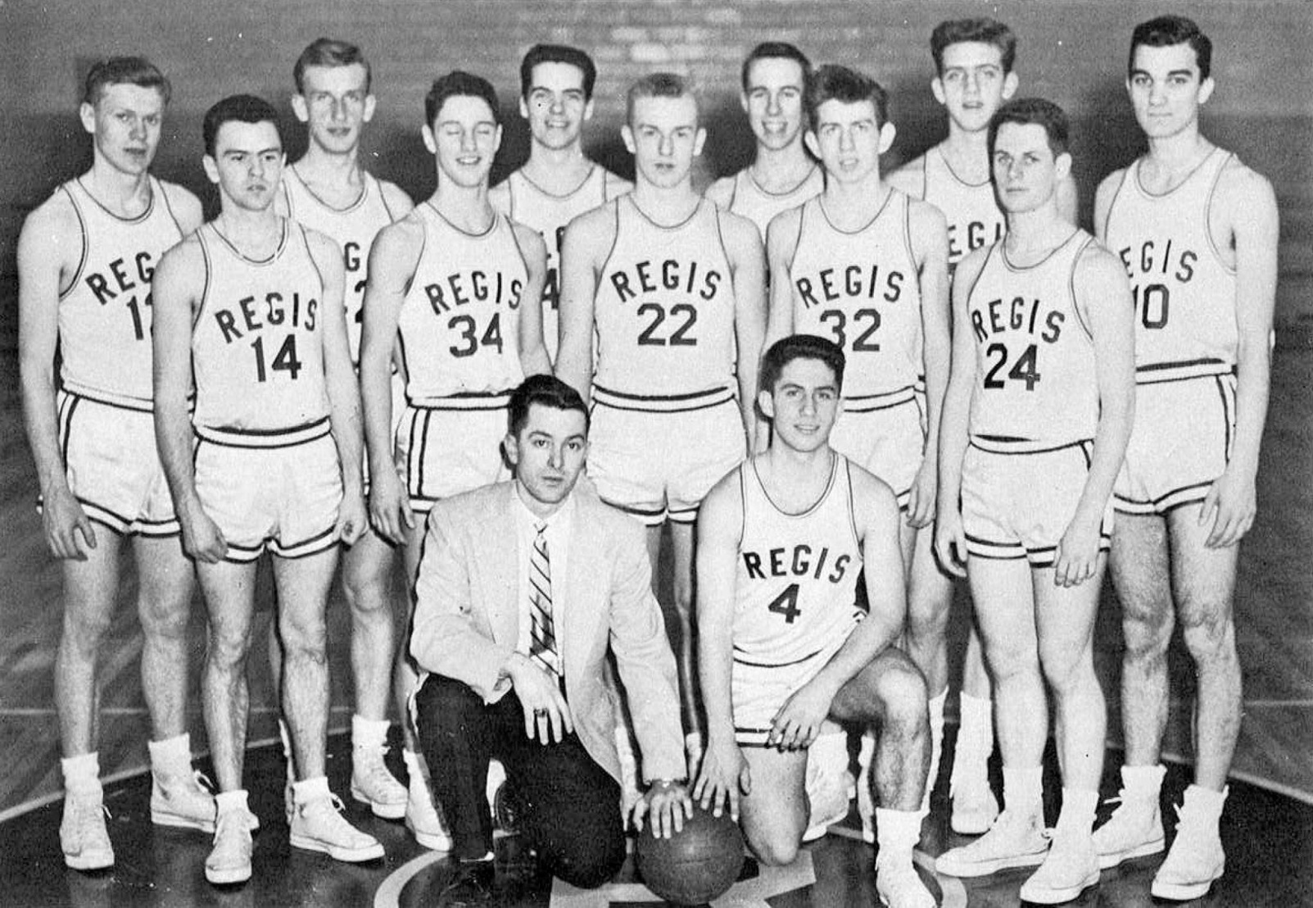

Unlike Spencer William Smith, formerly of Brunswick, Maine, player #4 above :

a. Was never told that he was in danger from Gain-of-Function (GOF) research conducted in an unqualified lab in Wuhan China, or anywhere else . . . research that was funded by some *‘telling the truth at all times’* bureaucrat who was connected to a criminal scheme to circumvent a US federal government moratorium on that very type of *very* dangerous GOF research. **[11]**

b. Player #4 was never told that he and his family had to cover their faces with grotesque masks at all times, even during Thanksgiving dinner, and the Christmas holidays . . . Player #4 was never lied to about the alleged effectiveness of such abject tyrannical stupidity, versus the true purpose of behavioral conditioning and societal compliance, as predicates for profit-prioritized and a carefully concealed pre-planned criminal scheme to make vaccination mandatory.

16 December 2020 Dr. Anthony S. Fauci

Page 12 of ??

**Discussion : The Destiny of Two Sixteen Year Old Boys – A Stark Comparison** – con’t

This photograph was taken in 1956. At the time, player #4 is 16 years old . . .

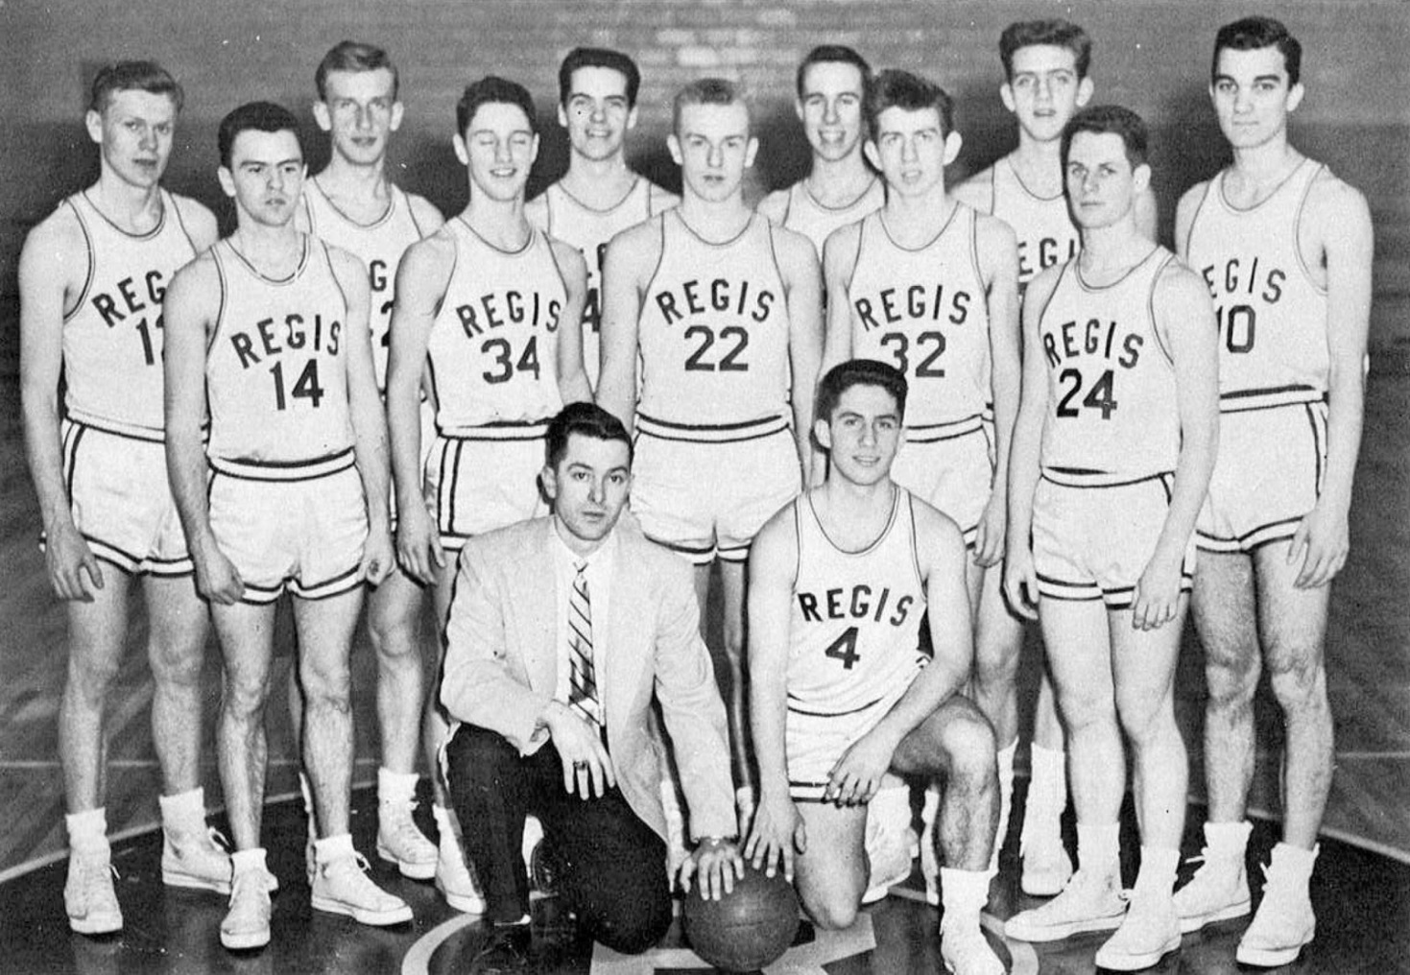

c. Player #4 was never told that getting stuck with a needle promoted by lawyers and politicians and psychotic computer hacks, for a disease that was routinely defeated by his

God-given immune system, **would be mandatory**, if he sought to travel, or attend university, or just enjoy the rigors and pleasures of daily life.

d. Unlike Spencer William Smith, player #4 was never told that his sports season was canceled due to the lie spewed by “health authorities” that the global spread of a virus originated

in bats, sold at a fish market (!?), versus the truth explained in Item a above.



16 December 2020 Dr. Anthony S. Fauci

Page 12 of ??

**Discussion : The Destiny of Two Sixteen Year Old Boys – A Stark Comparison** – con’t

This photograph was taken in 1956. At the time, player #4 is 16 years old . . .



e. Unlike Spencer William Smith, player #4 was never told by his governor that he and his family must submit his young life to a lockdown, leaving him disconnected from his high school friends during the most important time for social development . . . a disconnection that would endure, with no stated end in sight, justified on the basis of a “gold standard.”

Surprise outbreak

Censorship big tech social media condominium

L;ook at fauci ??s

Return to the nations not a one world gov think on this as keyhole get impassable

15 December 2020 Dr. Anthony S. Fauci

Page 12 of ??

**Intermission : Your Pandemic Resume**

<https://www.sun-sentinel.com/coronavirus/fl-ne-lab-results-20200715-r535ae72zjdwfekudu3poiy34e-story.html>

<https://www.brackettfh.com/obituaries/Spencer-William-Smith?obId=19220178>

Add lawsuit in germany

<https://youtu.be/YgOAaLmoa68> dr kory

<https://youtu.be/QKwHFXw-UaM> no trans from asym

<https://youtu.be/qIdcGxsW4XQ> dr risch

florida FLDOE link <http://www.fldoe.org/em-response/>

according to you Spencer died of “COVID 19”

<https://www.eurekalert.org/pub_releases/2020-08/inmn-hri082520.php>

near zero link <https://youtu.be/QmL05dCeukc>

<https://www.cdc.gov/coronavirus/2019-ncov/community/health-equity/race-ethnicity.html>

<https://health.cornell.edu/resources/especially-for/students-of-color/compliance-testing-flu-vaccine-requirements>

wuhan high school <https://www.worldpoliticsreview.com/articles/29136/why-china-s-coronavirus-propaganda-campaign-has-come-up-short>

<https://www.usnews.com/news/world/articles/2020-08-28/chinas-wuhan-says-all-schools-to-reopen-on-tuesday>

<https://health.cornell.edu/get-care/health-requirements-new-students/FAQ#exemption>

<https://health.cornell.edu/services/immunizations-allergy-shots/annual-flu-vaccination#exemption>

<https://health.cornell.edu/resources/especially-for/students-of-color/compliance-testing-flu-vaccine-requirements>

<https://www.cdc.gov/coronavirus/2019-ncov/community/health-equity/race-ethnicity.html>

<https://covid.cornell.edu/students/behavioral-compact/>

where update of 10 dec is

Governor Janet Mills   
1 State House Station   
Augusta, ME 04333   
207-287-3531

1. An e-version of this letter with hyperlinks: <http://pvsheridan.com/sheridan2fauci-2-14december2020.pdf>
2. It is evidentiary that you would seek to allay, in a globally distributed financial publication, the concerns of vested-interests, Big Pharma, etc.
3. I also requested that you offer the taxpayer **your** retraction, and an apology, regarding the Surgisphere “study,”

   but **characteristically** you have refused to *“tell the truth at all times.”*
4. It did not surprise anyone that the most embarrassing moment of that hearing is sourced to Mr. Gary Peters.
5. And now, characteristically for them, you are allied in the ‘vaccination = herd immunity’ stampede by the vested-interest administrators of Big Academia; see page 9 of Attachment 1.
6. Available at <http://pvsheridan.com/sheridan2bastian-1-24november2020.pdf>
7. You are discussed in my letter to the First Lady: <http://pvsheridan.com/Sheridan2Melania-3-23July2020.pdf>
8. See page 7 of Attachment 2. Has this gone on before? Regarding your vaccine failure for “HIV” . . . you spent millions of taxpayer dollars, while simultaneously denying/severely-delaying approval of AIDS treatments such as repurposed medicines.

   **30+ years later? This is the exact same profit-prioritized violation of the Hippocratic Oath that you are now dispensing for COVID-19! Dr. Mullis: “He should not be in the position he is in.”**
9. According to the shipper, [the Governor’s office received his copy on 27 July 2020](https://www.fedex.com/apps/fedextrack/?tracknumbers=128318100005388).
10. <https://www.brackettfh.com/obituaries/Spencer-William-Smith?obId=19220178>
11. See Attachment 2, Page 3, Question 1.